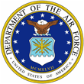 |  | 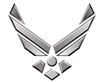
U N I T E D S T A T E S A I R F O R C E

LT COL NATHAN COLLINS
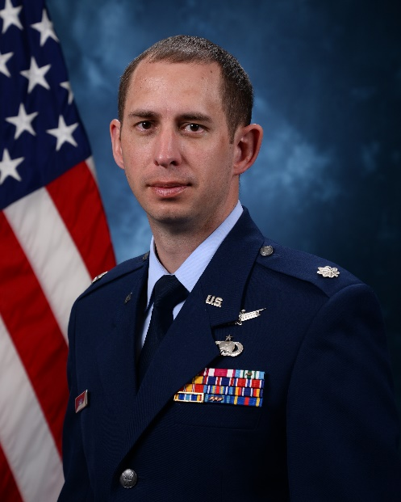
Lt Col Nathan S. Collins is currently the Director of Research and an Assistant Professor in the Department of Astronautics at the United States Air Force Academy, CO.

Lt Col Collins attended the United States Air Force Academy and graduated in 2006 with a bachelor's degree in Astronautical Engineering. He has served as a spacecraft branch chief, SPO technical director, program manager, and satellite operations engineer. In 2019, Lt Col Collins deployed in support of Operation Enduring Freedom as an NRO Liaison Officer. Lt Col Collins was selected to attend the Air Force Institute of Technology in 2009 where he earned a Master of Science Degree in 2011. He was also selected to attend the University of Surrey, Surrey Space Centre, in the United Kingdom where he earned his PhD in Electronic Engineering. In his previous assignment, Lt Col Collins served as the Spacecraft Branch Chief, TDSPO, Operational Defense Division, Survivability Assurance Office, NRO.

EDUCATION
2006 Bachelor of Science degree in Astronautical Engineering, USAFA, Colorado Springs, CO
2011 Master of Science degree in Astronautical Engineering, Air Force Institute of Technology, Dayton, OH
2016 Doctor of Philosophy degree in Electronic Engineering, University of Surrey, Guildford, UK

ASSIGNMENTS
- August 2006 – August 2009, GPS Navigation Payload Engineer, 2nd Space Operations Squadron, Schriever AFB, CO
- August 2009 – April 2011, Graduate Student, U.S. Air Force Institute of Technology, Wright-Patterson AFB, OH
- April 2011 – May 2012, Instructor, Department of Mathematics, U.S. Air Force Academy, CO
- May 2012 – June 2013, Instructor of Astronautics, Department of Astronautics, U.S. Air Force Academy, CO
- June 2013 – August 2013, Assistant Professor of Astronautics, Department of Astronautics, U.S. Air Force Academy, CO
- August 2013 – October 2016, Graduate Student, University of Surrey, Guildford, Surrey, United Kingdom
- October 2016 – October 2018, Chief, Advanced Systems Branch, Survivability Assurance Office, NRO, Chantilly, VA
- October 2018 – April 2019, Program Manager/Technical Director, XSPO, Survivability Assurance Office, NRO, Chantilly, VA
- April 2019 – October 2019, NRO LNO to Combined Air & Space Operations Center (CAOC), Al Udeid Air Base, Qatar
- October 2019 – August 2020, Spacecraft Branch Chief, TDSPO, Operational Defense Division, Survivability Assurance Office, NRO, Chantilly, VA
- August 2020 – June 2021, Deputy for Operations and Assistant Professor of Astronautics, Department of Astronautics, U.S. Air Force Academy, CO
- June 2021 – June 2022, Deputy Department Head and Assistant Professor of Astronautics, Department of Astronautics, U.S. Air Force Academy, CO
- June 2022 – Present, Director of Research and Assistant Professor of Astronautics, Department of Astronautics, U.S. Air Force Academy, CO

PROFESIONAL MILITARY EDUCATION
Air and Space Basic Course – Residence, 2006
Squadron Officer School – Correspondence, 2012; Residence, 2013
Air Command and Staff College – Correspondence, 2018
Air War College – Correspondence, 2022

MAJOR AWARDS AND DECORATIONS

Outstanding Academy Educator, Department of Astronautics (2022)

John P. Wittry Award, top instructor of Engineering Design, Department of Astronautics (2022)

Awarded Institute of Navigation’s Navigation Research Excellence Award, Air Force Institute of Technology (2011)

Defense Meritorious Service Medal

Meritorious Service Medal

Joint Service Commendation Medal with one oak leaf cluster

Air Force Commendation Medal

Air Force Outstanding Unit Award

National Defense Service Medal

Global War on Terrorism Expeditionary Medal

Global War on Terrorism Service Medal

EFFECTIVE DATES OF PROMOTION
Second Lieutenant May 31, 2006
First Lieutenant May 31, 2008
Captain May 31, 2010
Major October 1, 2016
Lieutenant Colonel July 1, 2021
(Current as of June 2022)

